# **Week 2: processing the data**

## **Setting up files and directories for ISCE2 TopsApp.py processing**

**Note: when running isce tools, you need to activate the anaconda environment where you installed isce. Type conda activate <environment name> to do that. Most people have isce2 as their environment name.**

1. Create a directory with the name ‘InSARworkshop’ in the scratch folder.

Scratch folder is located at ‘/lustre/scratch/<your username without quotes>/’. To create the directory, type:

conda activate isce2

cd /lustre/scratch/<your username without quotes>

mkdir InSARworkshop

cd InSARworkshop

pwd

The last line changes the directory to the newly created ‘InSARworkshop’ directory.

Note: To check which directory you are in, type pwd and hit enter. If it shows you any other result than /lustre/scratch/<your username without quotes>/InSARworkshop, then type cd /lustre/scratch/<your username without quotes>/InSARworkshop and hit enter.

1. In the ‘InSARworkshop’ directory, create another directory with name ‘DT71’.

For this, type:

mkdir DT71

cd DT71

DT71 corresponds to the descending track 71 of the Sentinel-1 satellite acquisition.

1. In the ‘DT71’ directory, create three directories with names ‘SLCs’, ‘DEM’, and ‘20200511_20200517’.

For this type:

mkdir SLCs

mkdir DEM

mkdir 20200511_20200517

In the SLCs directory, we will store the single look complex images in the ‘*.SAFE.zip’ format that we will download from the ASF facility.

In the DEM directory, SRTM 30 m resolution digital elevation model will be stored.

We will carry out InSAR processing in 20200511_20200517 directory. 20200511 corresponds to the date of first acquisition, which is 11th May 2020, and 20200517 corresponds to the date of second acquisition.

1. Next we will get the single look complex images (SLC files) from the ASF facility. If you have not already, then sign up on the website <https://urs.earthdata.nasa.gov/> .

Then, go to the website <https://search.asf.alaska.edu/> . Left click on ‘filters’ (see below)

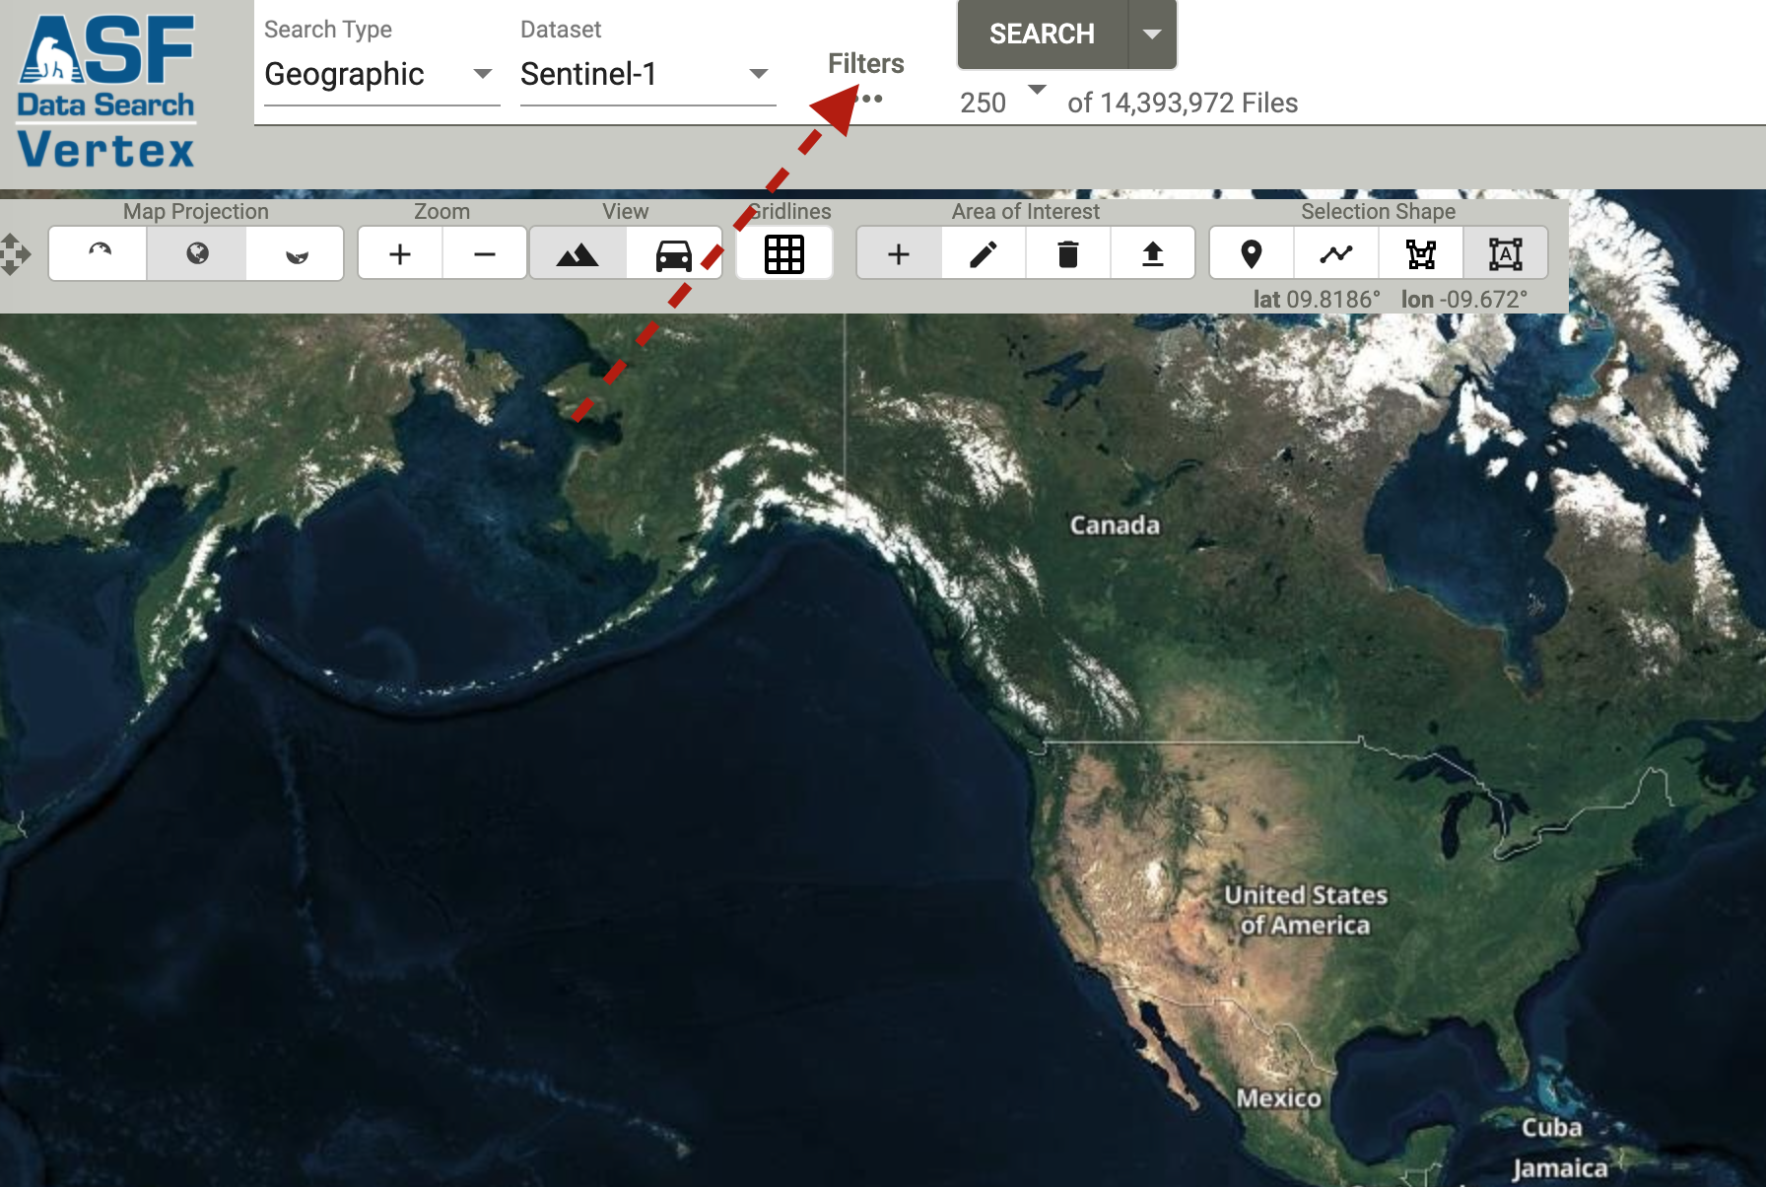

That should open a dialog box as you see below:

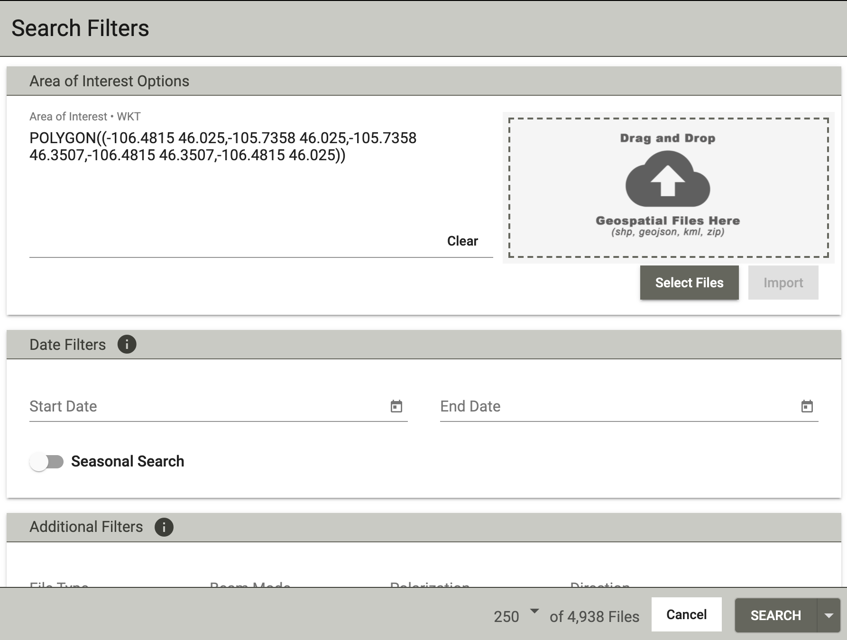

In the Area of Interest, copy and paste the following:

POLYGON((-118.4933 37.8424,-116.8459 37.8424,-116.8459 38.7055,-118.4933 38.7055,-118.4933 37.8424))

Set the start date as 5/10/2020 and the end date as 5/18/2020. Now the dialog box should look like as below:

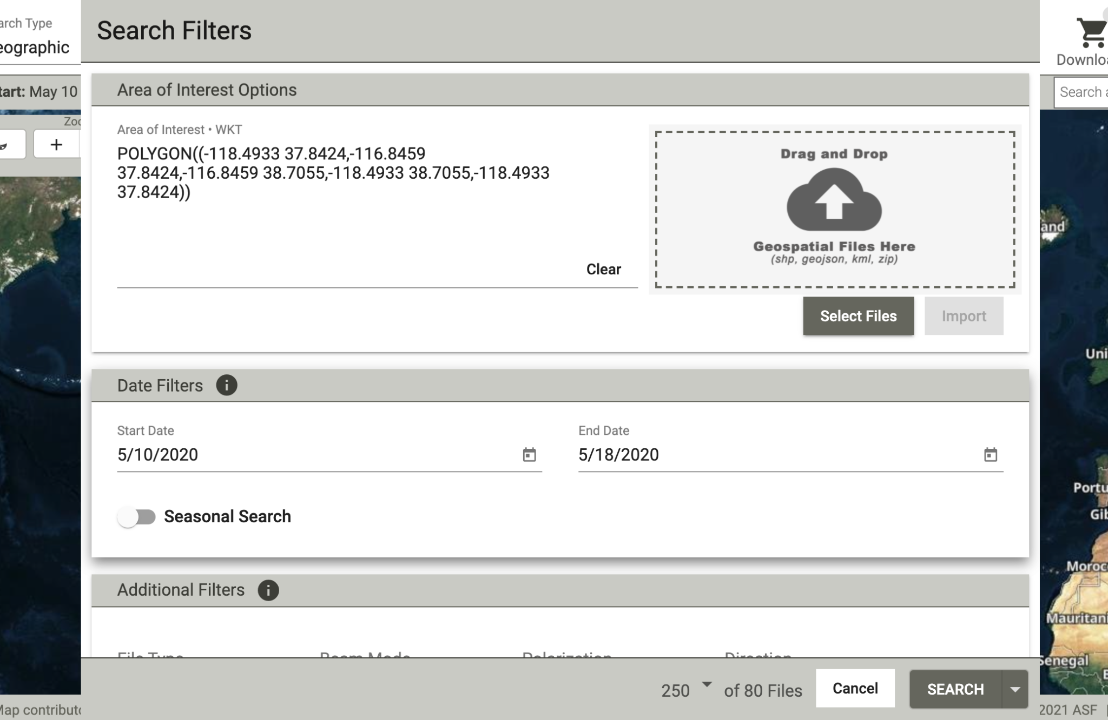

Scroll down the dialog box to find ‘Additional filters’. Set the ‘File Type’ to ‘L1 Single Look Complex (SLC)’ as below:

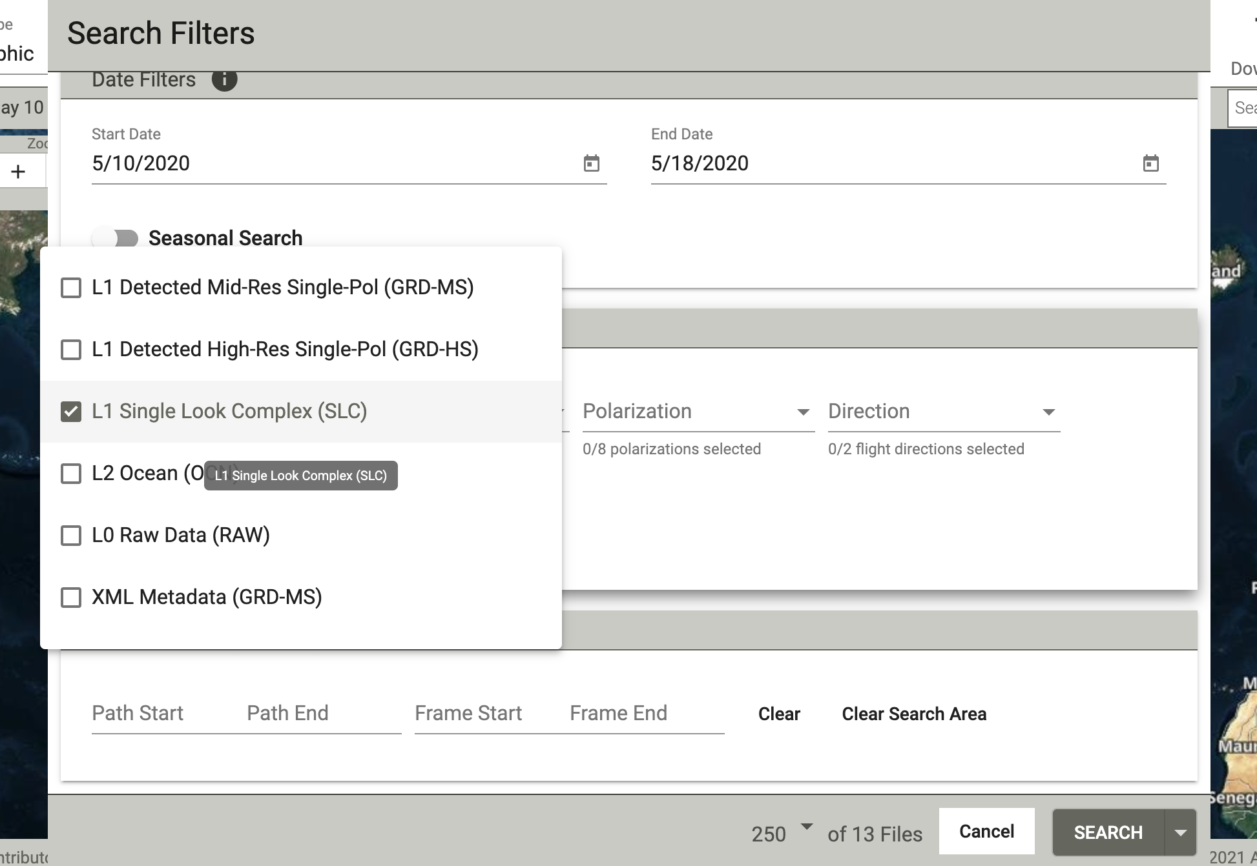

Set the ‘Direction’ to ‘Descending’ as below:

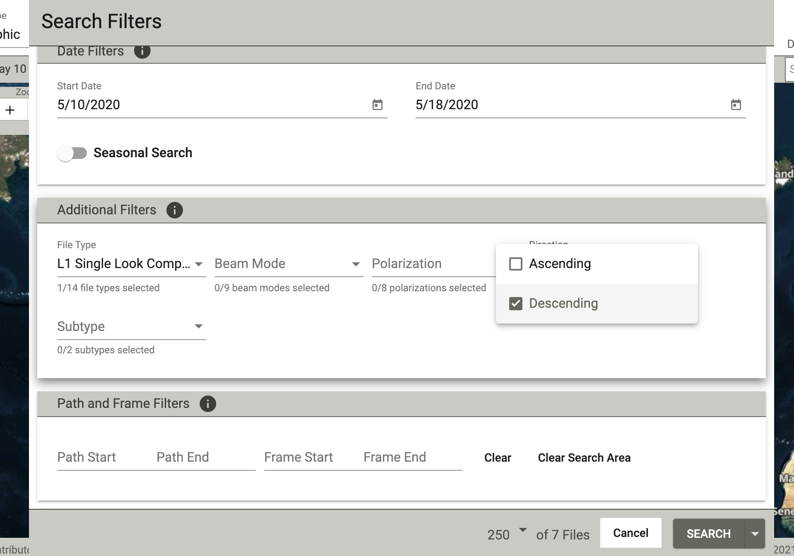

Under Path and Frame Filters, set the ‘Path Start’ as 71 and ‘Path End’ as 71. Set the ‘Frame Start’ as 463 and ‘Frame End’ as 465. Now the dialog box should look as below:

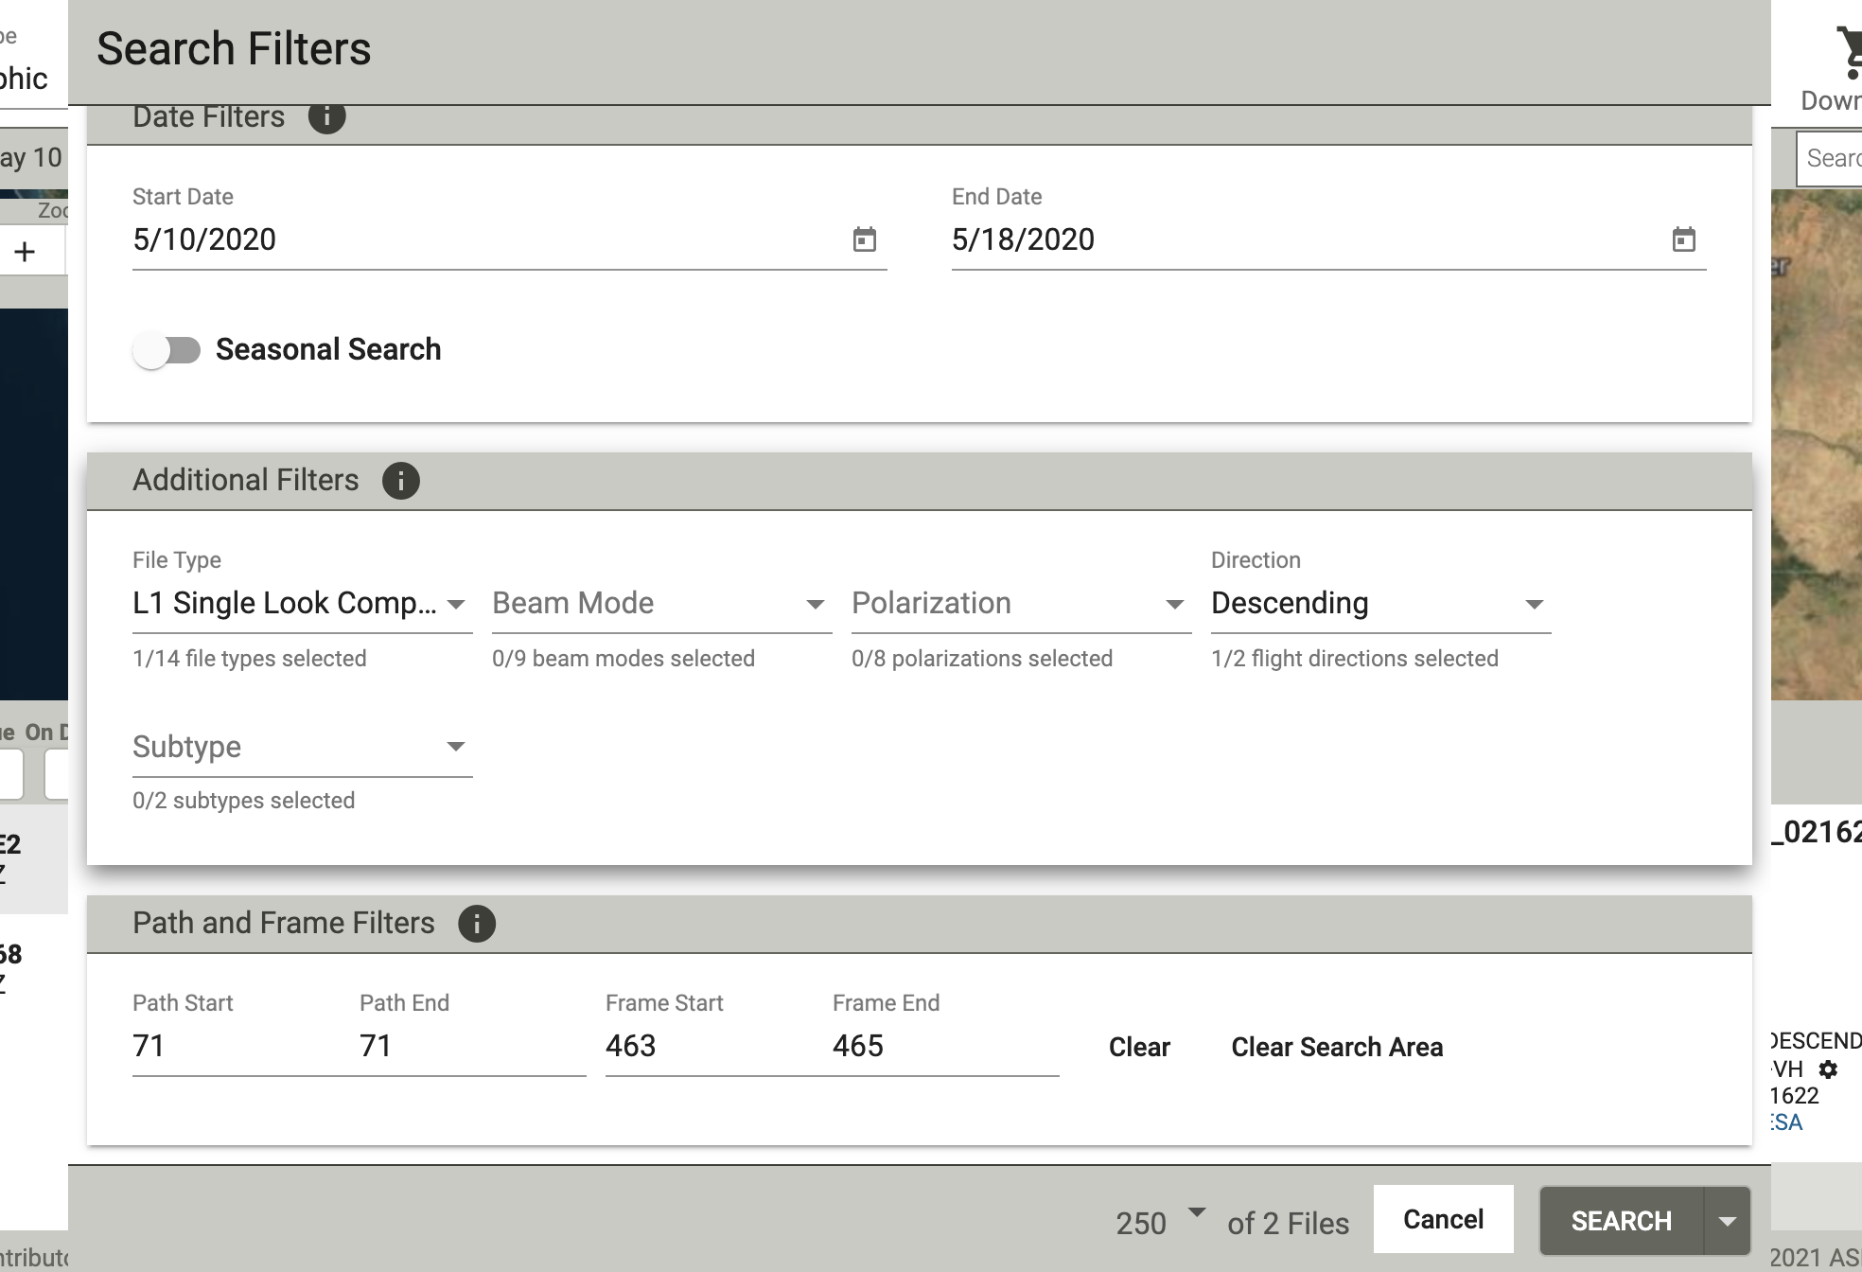

Leave the other options as it is and hit ‘SEARCH’ at the bottom right of the dialog box.

As you hit SEARCH, the ASF window should look like as below:

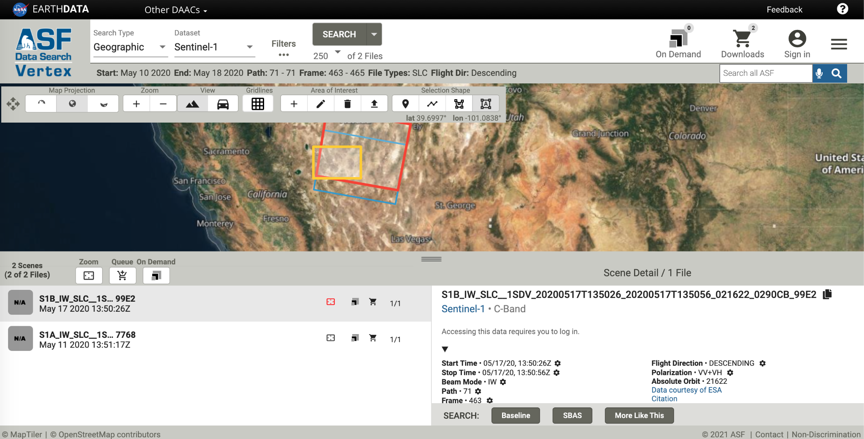

Then hit the ‘cart’ logo as shown below and select ‘Add 2 files to download’. See below:

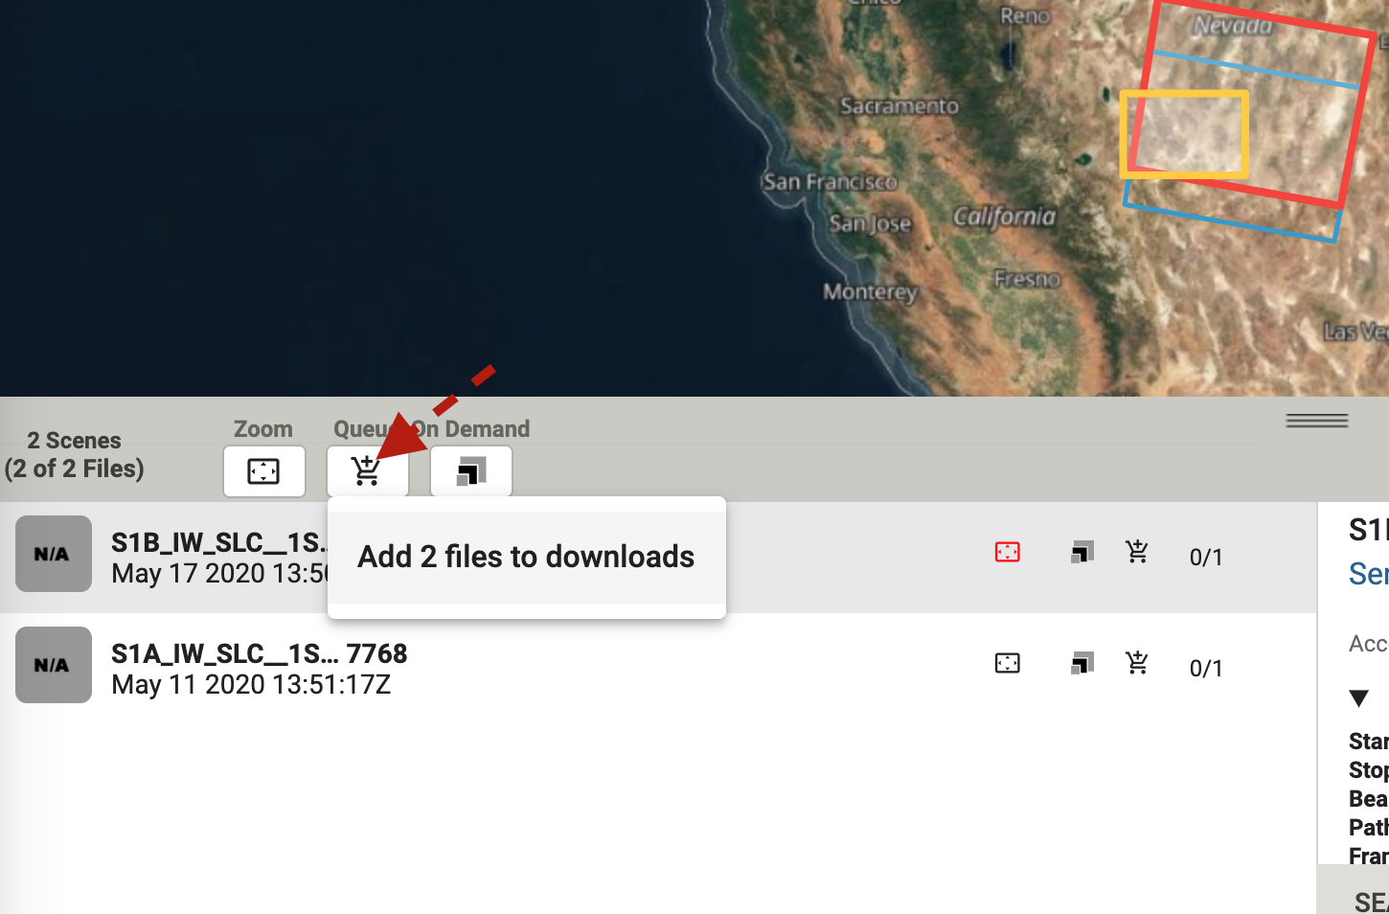

Next left click on ‘Downloads’ with cart logo at the top right of the page. That should open another dialog box as below:

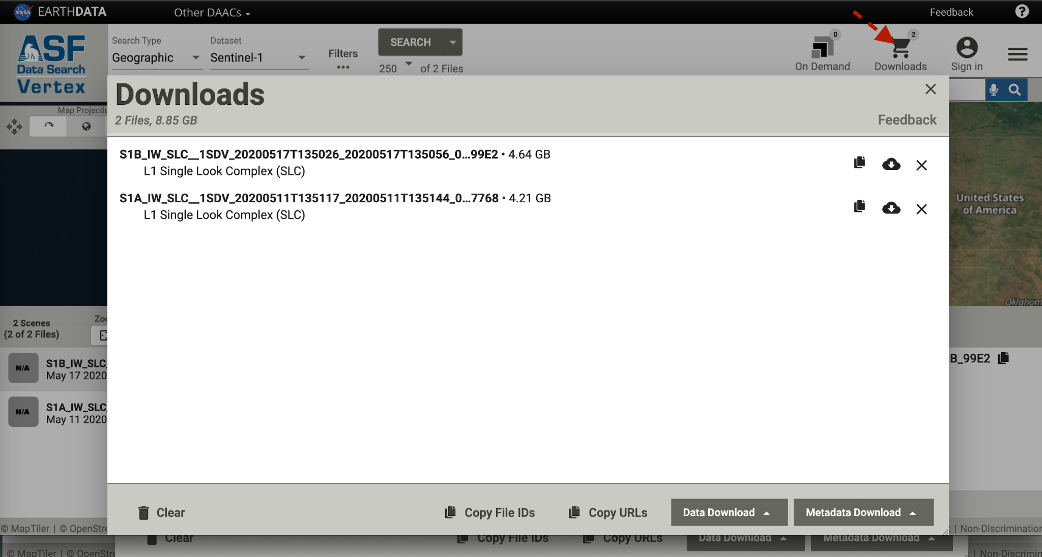

In this dialog box, click on ‘Data Download’ at bottom right and select ‘Download Python Script (.py)’ and ‘Metadata (metalink)’ one by one to download two files with names similar to (not everyone will have the same filename):

download-all-2021-10-21_02-42-14.py

asf-datapool-results-2021-10-20_09-42-11.metalink

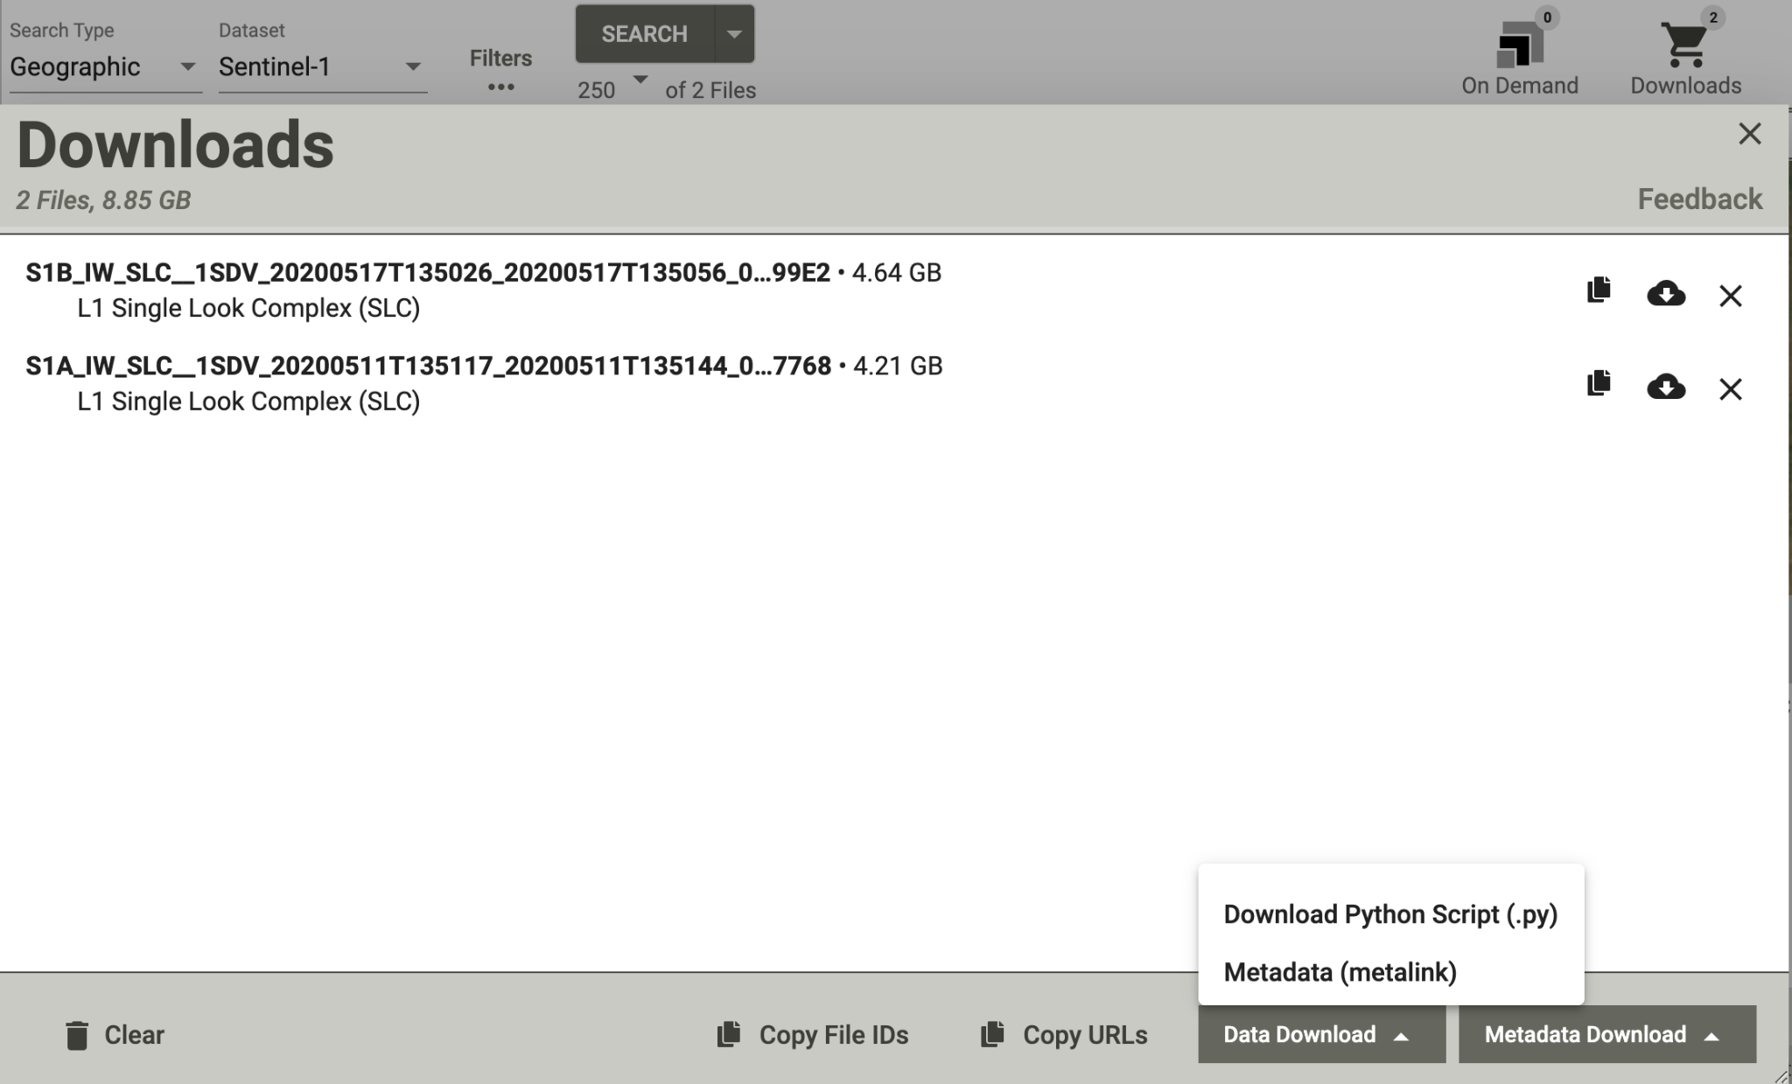

1. Now we have to transfer these two downloaded files to the ‘SLCs’ directory that we created in Foundry. For ease, I have already added these files to a Github folder. Type the following:

cd /lustre/scratch/<your username without quotes>/InSARworkshop/DT71/SLCs

pwd

git clone https://github.com/rishabhdutta/InSAR_utils

cp InSAR_utils/plot_workshop/asf* .

cp InSAR_utils/plot_workshop/download* .

ls

(Note: don’t miss the dot in the line above)

Go to <https://urs.earthdata.nasa.gov/profile>

Now we have to use these files to download the SLC image files in .SAFE.zip format. To do this, type:

python ./download-all-2021-10-14_22-40-09.py asf-datapool-results-2021-10-14_05-40-07.metalink

(above is single line)

(Note: the above line is a single line script. )

This will prompt you to enter username and password. Use the username and password that you used to signup in the website <https://urs.earthdata.nasa.gov/>.

Wait until the files are downloaded and finally you should be able to see these two files in the directory:

ls

S1A_IW_SLC__1SDV_20200511T135117_20200511T135144_032518_03C421_7768.zip

S1B_IW_SLC__1SDV_20200517T135026_20200517T135056_021622_0290CB_99E2.zip

To see the contents in the directory, type ls and hit enter.

1. Next we download the orbit files for the corresponding SLC file that are downloaded. Check if you are still in the SLCs directory by typing pwd and hit enter. The result should be /lustre/scratch/<your username without quotes>/InSARworkshop/DT71/SLCs

If it doesn’t, then type the following:

cd /lustre/scratch/<your username without quotes>/InSARworkshop/DT71/SLCs

Make a directory with name ‘orbits’ in the ‘SLCs’ directory as below:

mkdir orbits

cd orbits

cd ..

Then to download the orbit files, type the following two lines and hit enter:

fetchOrbit.py -i S1A_IW_SLC__1SDV_20200511T135117_20200511T135144_032518_03C421_7768.zip -o orbits/

fetchOrbit.py -i S1B_IW_SLC__1SDV_20200517T135026_20200517T135056_021622_0290CB_99E2.zip -o orbits/

This should download the following orbit files:

ls orbits

S1A_OPER_AUX_POEORB_OPOD_20210318T120818_V20200510T225942_20200512T005942.EOF

S1B_OPER_AUX_POEORB_OPOD_20210318T091257_V20200516T225942_20200518T005942.EOF

To check the contents of ‘orbits’ directory, type ls orbits/ and hit enter.

1. Next, we are going to download SRTM 30 m resolution DEM. For this step, we have to navigate to the home directory by typing cd and hit enter.

Alternatively, you can type cd /home/<your username without quotes>/ and hit enter.

type nano .netrc

type the following scripts in .netrc

machine urs.earthdata.nasa.gov

login <replace with your login name in urs.earthdata.nasa.gov>

password <replace with the password>

Hit control+O, then enter, to save, and control+X to exit

more .netrc

bash

conda activate isce2

Note: use the same indentation as shown above.

Then the directory has to be changed by typing

cd /lustre/scratch/<your username without quotes>/InSARworkshop/DT71/DEM

In the folder, type the following:

dem.py -a stitch -b 36 40 -120 -115 -r -s 1 -c

The following files will be created that you can see typing ls

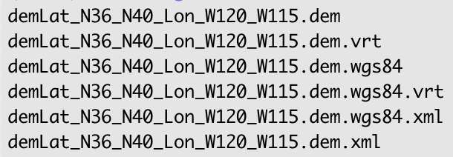

To see if the contents of the files are correct, type below:

gdalinfo -stats demLat_N36_N40_Lon_W120_W115.dem.wgs84

You should be able to see the following results:

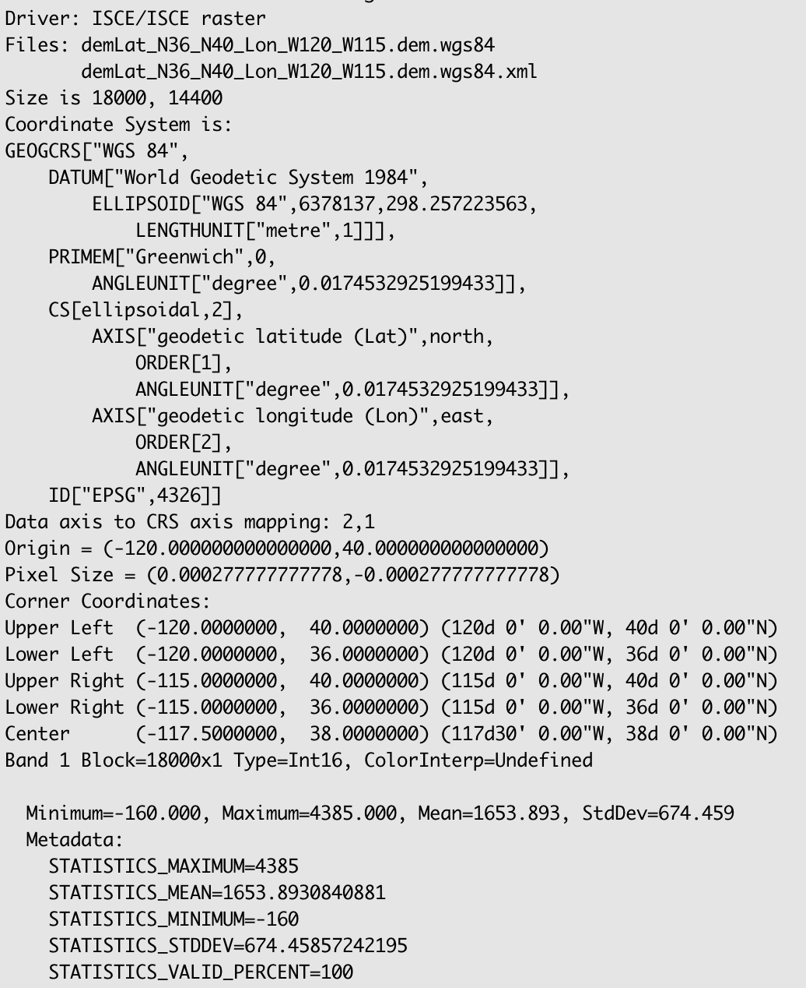

If the STATISTICS MAXIMUM, MEAN, MINIMUM are all zeros, then the DEM download failed due to server down.

1. Now that we have the SLCs, orbits, and the DEM. We will set up the InSAR processing directory. Type

cd /lustre/scratch/<your_username_without_quotes>/InSARworkshop/DT71/20200511_20200517

Here, you have to create four text files, namely topsApp.xml, reference.xml, secondary.xml, and batch.bsub.

To run topsApp.py, all the input variables are controlled from xml app files. Batch.bsub file is required to run the topsApp.y app in the compute node.

Note: we are not using sinteractive for the next steps.

To put the contents in the topsApp.xml, type vi topsApp.xml and hit i button

You should be seeing the below:

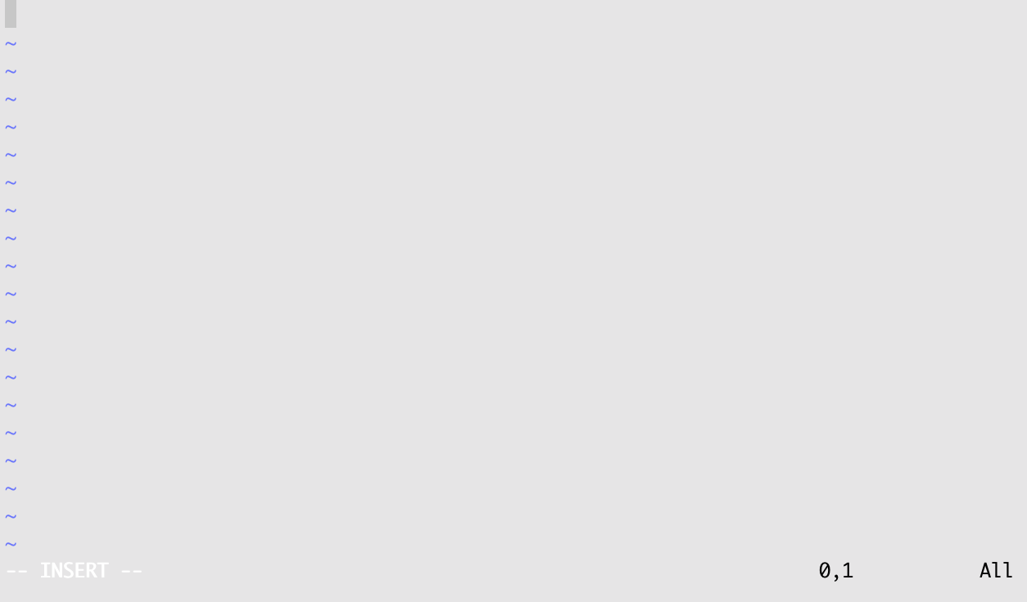

If you don’t see -- INSERT -- at the bottom left, hit i button again.

Next, copy the following lines highlighted in light gray and paste into the editor

<?xml version="1.0" encoding="UTF-8"?>

<topsApp>

<component name="topsinsar">

<property name="Sensor name">SENTINEL1</property>

<component name="reference">

<catalog>reference.xml</catalog>

</component>

<component name="secondary">

<catalog>secondary.xml</catalog>

</component>

<property name="swaths">[3]</property>

<property name="range looks">7</property>

<property name="azimuth looks">3</property>

<property name="region of interest">[37.75, 38.75, -118.21, -117.4]</property>

<property name="do unwrap">True</property>

<property name="unwrapper name">snaphu_mcf</property>

<property name="do denseoffsets">True</property>

<property name="demfilename">/lustre/scratch/<your username>/InSARworkshop/DT71/DEM/demLat_N36_N40_Lon_W120_W115.dem.wgs84</property>

<!--<property name="geocode demfilename">path_to_your_dem</property>-->

<!--property name="geocode list">['merged/phsig.cor', 'merged/filt_topophase.unw', 'merged/los.rdr', 'merged/topophase.flat', 'merged/filt_topophase.flat','merged/topophase.cor','merged/filt_topophase.unw.conncomp']</property>-->

</component>

</topsApp>

To save, hit the Escape button and type :wq! and hit Enter.

more topsApp.xml

Next edit the reference.xml file. Type vi reference.xml and hit i button. Copy the following lines highlighted in light gray and paste into the editor

<component name="reference">

<property name="orbit directory">../SLCs/orbits/</property>

<property name="output directory">reference</property>

<property name="safe">['../SLCs/S1A_IW_SLC__1SDV_20200511T135117_20200511T135144_032518_03C421_7768.zip']</property>

</component>

To save, hit the Escape button and type :wq! and hit Enter.

Now edit the secondary.xml file. Type vi secondary.xml and hit i button. Copy the following lines highlighted in light gray and paste into the editor

<component name="secondary">

<property name="orbit directory">../SLCs/orbits/</property>

<property name="output directory">secondary</property>

<property name="safe">['../SLCs/S1B_IW_SLC__1SDV_20200517T135026_20200517T135056_021622_0290CB_99E2.zip']</property>

</component>

To save, hit the Escape button and type :wq! and hit Enter.

To edit the batch.bsub file, Type vi batch.bsub and hit the I button. Copy the following lines highlighted in light gray and paste into the editor

#!/bin/bash

#SBATCH --job-name=topsApp

#SBATCH --ntasks=1

#SBATCH --time=1-00:00:00

#SBATCH --mail-type=begin,end,fail,requeue

#SBATCH --mail-user=<your mst email ID>@mst.edu

#SBATCH --export=all

#SBATCH --out=Foundry-%j.out

#SBATCH --mem-per-cpu=200000

# %j will substitute to the job's id

#now run your executables just like you would in a shell script, Slurm will set the working directory as the directory the job was submitted from.

#e.g. if you submitted from /home/blspcy/softwaretesting your job would run in that directory.

#(executables) (options) (parameters)

echo "this is a general submission script"

echo "I've submitted my first batch job successfully"

start=`date +%s`

topsApp.py --start=startup --end=geocode

echo "job finished"

end=`date +%s`

runtime=$((end-start))

echo $runtime

To save, hit the Escape button and type :wq! and hit Enter.

## **Run ISCE2 TopsApp.py processing**

1. Now to run the ISCE processing using topsApp.py, remember to be in the processing directory 20200511_20200517.

If you are in some other directory, type

cd /lustre/scratch/<your username without quotes>/InSARworkshop/DT71/20200511_20200517

Now execute the bsub file by typing

sbatch batch.bsub

You can check if the job is running by typing

squeue -u <your username without quotes>

You should find a Foundry-<job ID>.out file created in the folder. This gives the output of all of the processes that are running. If everything is working, all steps for interferogram generation should go on their own now, and take ~1 hour. You can check that it’s working by typing

ls *Foundry*

To get the filename of your Foundry output file. Copy that filename, then

more <Foundry filename from previous step>

To view the file. Hit spacebar to go down a page, enter to scroll line by line. Hit q to leave the text viewer. If you see any ‘Traceback’ lines, that means there was some error. The most common error has been that the .xml files were not created correctly. Check those based on the previous instructions and try running again, if there was an error.

1. Type topsApp.py --help --steps and hit enter.

This shows you all the steps that you can run with topsApp.py.

## **Visualize ISCE2 TopsApp.py processing results**

I have added three scripts for plotting the result to Github. First we get those scripts. In the directory 20200511_20200517, type the following:

git clone <https://github.com/rishabhdutta/InSAR_utils>

cp InSAR_utils/plot_workshop/* .

(Note: don’t miss the dot in the above line)

1. After step startup, type

ls PICKLE

1. After step preprocess, type

ls reference/*

1. After step topo, type

ls geom_reference/*

gdalinfo -stats geom_reference/IW3/los_02.rdr.vrt

python plotdata.py -f 'geom_reference/IW3/hgt_01.rdr' -b 1 -t 'IW3: Height of Burst 1 [meter]' -c terrain -o output1.png

python plotdata.py -f 'geom_reference/IW3/hgt_01.rdr' -b 1 -t 'IW3: Incidence angle of Burst 1 [degrees]' -c jet -o output2.png

python plotdata.py -f 'geom_reference/IW3/los_01.rdr' -b 2 -t 'IW3: Azimuth angle of Burst 1 [degrees]' -c jet -o output3.png

1. After step subsetoverlaps, type

ls reference/overlaps/*

vim reference/overlaps/bottom_IW3.xml

python plotcomplexdata.py -f reference/overlaps/IW3/burst_bot_01_02.slc.vrt -t 'bot_01_02 (from Burst 2)' -a 10 -dmin 0 -dmax 200 -o output1.png

python plotcomplexdata.py -f reference/overlaps/IW3/burst_top_01_02.slc.vrt -t 'top_01_02 (from Burst 1)' -a 10 -dmin 0 -dmax 200 -o output2.png

python plotcomplexdata.py -f reference/IW3/burst_01.slc.vrt -t 'Burst 1' -a 10 -dmin 0 -dmax 200 -o output3.png

python plotcomplexdata.py -f reference/IW3/burst_02.slc.vrt -t 'Burst 1' -a 10 -dmin 0 -dmax 200 -o output4.png

1. After step coarseoffsets, type

ls coarse_offsets/overlaps/IW3/*

python plotdata.py -f coarse_offsets/overlaps/IW3/azimuth_bot_01_02.off.vrt -b 1 -t 'Azimuth bot_01_02' -c gray -a 10 -o output1.png

gdalinfo -stats coarse_offsets/overlaps/IW3/range_bot_01_02.off.vrt

python plotdata.py -f coarse_offsets/overlaps/IW3/range_bot_01_02.off.vrt -b 1 -t 'Range bot_01_02' -c gray -a 10 -o output2.png

gdalinfo -stats coarse_offsets/overlaps/IW3/range_bot_01_02.off.vrt

1. After step coarseresamp, type

ls coarse_coreg/overlaps/IW3/*

1. After step overlapifg, type

ls coarse_interferogram/overlaps/IW3*

python plotstackcomplexdata.py -f 'coarse_interferogram/overlaps/IW3/burst_top_*.3alks_7rlks.int' -t ' Top overlaps ' -a 10 -dmin 0 -dmax 6000 -o output1.png

1. After step esd, type

ls ESD/combined* ESD/ESDmisregistration*

# Plot ESD coherence

python plotdata.py -f ESD/combined_IW3.cor -b 1 -t ' coherence [-] ' -a 10 -dmin 0 -dmax 1 -o output1.png -bgnd yes

# Plot double difference interferogram

python plotcomplexdata.py -f ESD/combined_IW3.int -t ' Diff IFG [-] ' -a 10 -dmin 100000 -dmax 100000000 -o output2.png

Check ESD/ESDmisregistration.png

Check ESD/rangeMisregistration.jpg

1. After step rangecoreg

ls ESD

1. After step fineoffsets

ls fine_offsets/*

1. After step fineresamp

ls coreg_fine

1. After step burstifg

ls fine_interferogram/*

python plotcomplexdata.py -f fine_interferogram/IW3/burst_03.3alks_7rlks.int.vrt -t ' Burst 3 IFG ' -a 3 -dmin 0 -dmax 10000 -o output1.png

1. After step mergebursts

python plotcomplexdata.py -f merged/topophase.flat.vrt -t 'MERGED IFG ' -a 3 -dmin 0 -dmax 10000 -o output2.png

1. After step filter

python plotcomplexdata.py -f merged/topophase.flat.vrt -t ' MERGED IFG ' -a 3 -dmin 0 -dmax 10000 -o output3.png

python plotcomplexdata.py -f merged/filt_topophase.flat.vrt -t ' MERGED FILT IFG ' -a 1 -dmin 0 -dmax 10000 -o output4.png

1. After step unwrap

python plotdata.py -f merged/filt_topophase.unw -b 2 -t ' UNW FILT IFG [rad] ' -c jet -o output1.png

python plotdata.py -f merged/filt_topophase.unw.conncomp -b 1 -t ' UNW CONN COMP [-] ' -c jet -o output2.png

1. After step geocode

python plotdata.py -f merged/filt_topophase.unw.geo -b 2 -t 'UNW GEO FILT IFG [rad]' -c jet -o output3.png -dmin -20 -dmax 50

Also try typing -

python plotcomplexdata.py -f merged/reference.slc.full.vrt -t ' ` reference SLC ' -a 3 -dmin 0 -dmax 200 -o output1.png

python plotcomplexdata.py -f merged/secondary.slc.full.vrt -t ' secondary SLC ' -a 3 -dmin 0 -dmax 200 -o output1.png